**NAGALAND ELECTRICITY REGULATORY COMMISSION**

**(NERC)**

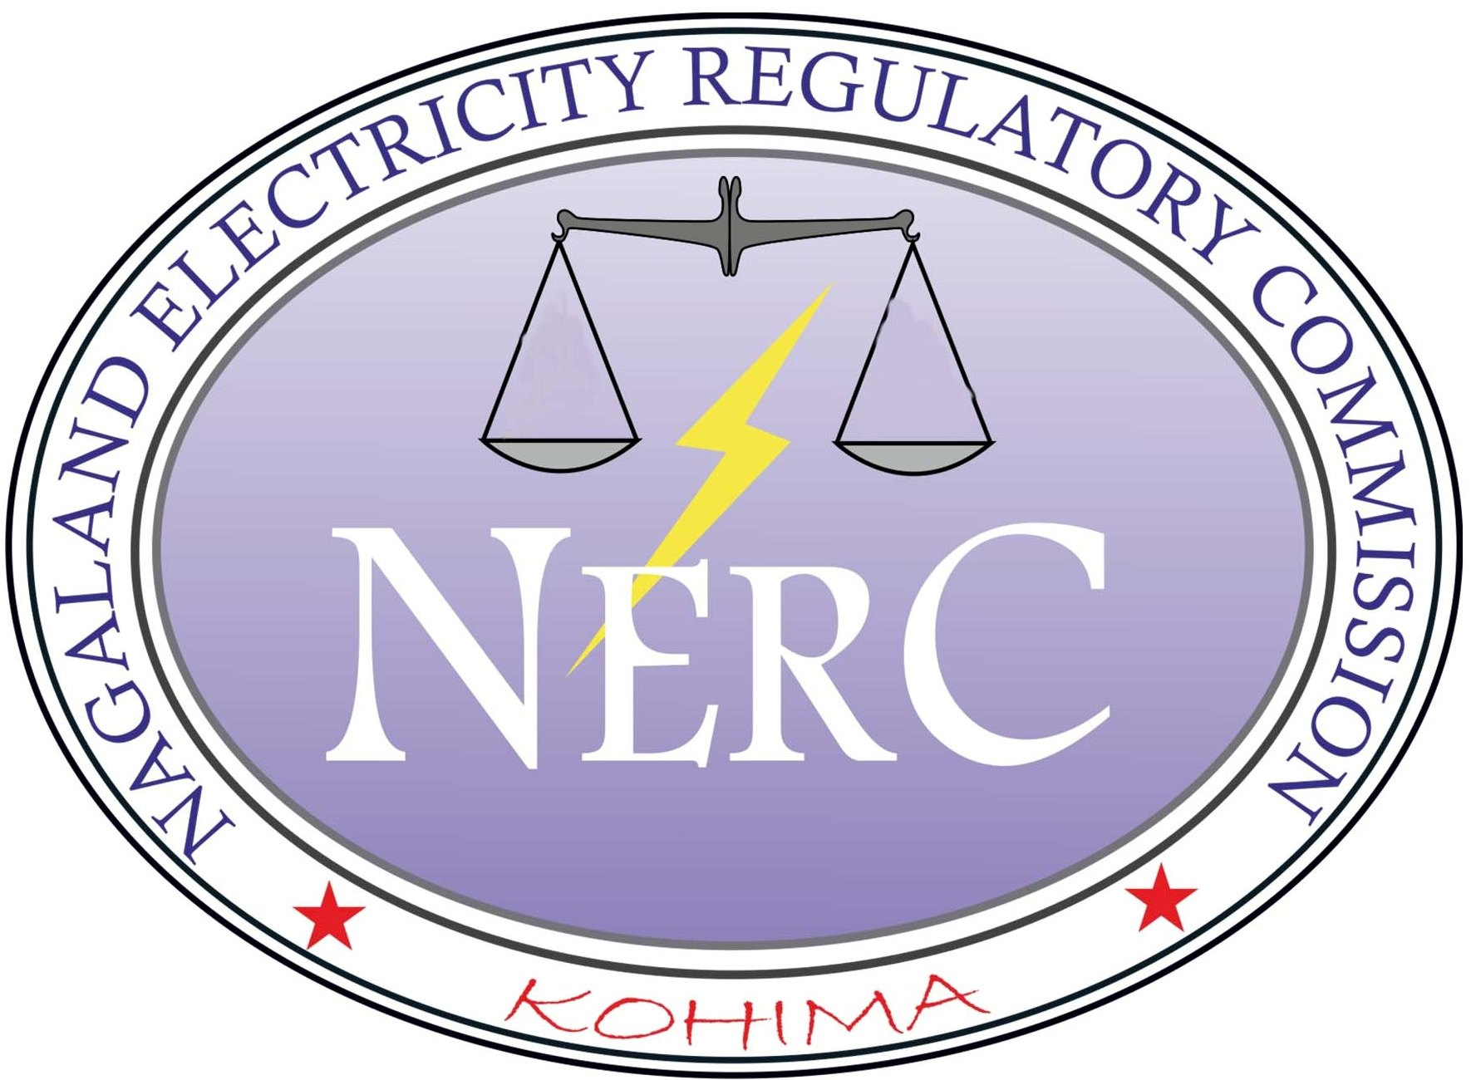

**No. NERC/REGN/T-15/2021 (Part-II) Dated Kohima, the 30th Sept, 2024**

#### **REGULATIONS**

**on**

**Methodology for determination of Green Energy**

**Open Access Charges**

*Near E-in-C Office, Department of Power*

*Nagaland, Kohima.*

*e-mail*: [nerc_kohima@yahoo.com/](mailto:nerc_kohima@yahoo.com/)website: *www.nerc.org.in*

**Old MLA Hostel Complex, Nagaland : Kohima-797001**

*Phone*: (0370) 2292101(O)/2241592 (R)/ *Fax*: 2292104(O)

e-mail: [*nerc_kohima@yahoo.com/*](mailto:nerc_kohima@yahoo.com/) website: *www.nerc.org.in*

**NAGALAND ELECTRICITY REGULATORY COMMISSION**

**NAGALAND ELECTRICITY REGULATORY COMMISSION**

No.NERC/REGN/T-15/2021(Part-II) Dated: 30-09-2024

# NOTIFICATION

In exercise of the powers conferred under section 181 of the Electricity Act, 2003 (36 of 2003), read with section 42, section 61 and section 86 thereof and all other powers enabling it in this behalf and after previous publication, the Nagaland Electricity Regulatory Commission hereby makes the following Regulations, namely-

# CHAPTER 1

# PRELIMINARY

## Short Title, Extent and Commencement

* 1. These Regulations shall be called as the Nagaland Electricity Regulatory Commission (Methodology for determination of Green Energy Open Access Charges) Regulations, 2024.
  2. These Regulations will come into force from the date of their notification in the Official Gazette.
  3. These Regulations shall extend to the whole of the State.

## Objective

The objective of these regulations is to provide a methodology for the determination of Open Access charges and Banking charges for Green Energy Open Access consumers.

## Definitions

## In these regulations, unless the context otherwise requires,

* + 1. "Act" means the Electricity Act, 2003(36 of 2003);
    2. “Banking” means the surplus green energy scheduled and injected into the grid and credited with the distribution licensee by the Green Energy Open Access consumers;
    3. ‘Central Commission’ means the Central Electricity Regulatory Commission referred to in sub-section (1) of Section 76 of the Act;
    4. “Central Nodal Agency” means a Central Nodal Agency as notified by the Central Government to set up and operate a single window green energy open access system for renewable energy;
    5. “Commission” means the Nagaland Electricity Regulatory Commission constituted under the Act;
    6. “Day Ahead Market (DAM)” means a market where Day Ahead Contracts are transacted on the Power Exchange(s);
    7. “Forum of Regulators” means the Forum as referred to in sub-section (2) of section 166 of the Act;
    8. “Fossil Fuel” means fuels such as coal, lignite, gas, liquid fuel or combination of these as its primary source of energy, which are used in Thermal Generating Station for generating electricity;
    9. “Green Energy” means the electrical energy from renewable sources of energy including hydro and storage (if the storage uses renewable energy) or any other technology as may be notified by the Government of India from time to time and shall also include any mechanism that utilizes green energy to replace fossil fuels including production of green hydrogen or green ammonia as per provision of clause G of sub-rule (2) of rule 4 of Green Energy Open Access Rules, 2022;
    10. “Green Open Access Consumer” means any person who has contracted demand or sanctioned load of 100kW or more or such other limit as may be specified by Commission from time to time, except for captive consumers, who are supplied with electricity from green energy sources for their own use by a licensee or the Government or by any other person engaged in the business of supplying electricity to the public under this Act or any other law for the time being in force and includes any person whose premises are for the time being connected for the purpose of receiving green energy with the works of a licensee, the Government or such person, as the case may be.
    11. “Rules” means the Electricity (Promoting Renewable Energy Through Green Energy Open Access) Rules, 2022 and subsequent amendments;
    12. “SERC” means the State Electricity Regulatory Commission;
    13. “Standby charges” means the charges applicable to green energy open access consumers against the standby arrangement provided by the distribution licensee, in case such green energy open access consumer is unable to procure/schedule power from the generating sources with whom they have the agreements to procure power due to outages of generator, transmission systems and the like;
  1. Words and expressions used and not defined in these regulations but defined in the Act or IEGC or any other regulation of the Appropriate Commission shall have the meaning assigned to them under the Act or the IEGC or the State Grid Code or any other regulation of the Commission as the case may be.

## Scope

These regulations shall be applicable for allowing Open Access to electricity generated from green energy sources as defined under clause (1) (i) of Regulation 3 of these Regulations, including the energy from non-fossil fuel-based Waste-to-Energy plant for use of Intra-State Transmission System (InSTS) or distribution system or both, which are incidental to Inter- State Transmission of electricity.

# CHAPTER 2

**GREEN ENERGY OPEN ACCESS CHARGES**

## Charges for Green Energy Open Access

The charges on Green Energy Open Access consumers shall be as follows: -

* 1. Transmission charges;
  2. Wheeling charges;
  3. Cross subsidy Surcharge;
  4. Standby charges wherever applicable;
  5. Banking Charge and
  6. Other fees and charges such as SLDC fees and scheduling charges, deviation settlement (DSM) charges as per the relevant regulations of the Commission.

## Transmission Charges

1. **For use of inter-State transmission system**:

As specified by the Central Commission from time to time.

1. **For use of intra-State transmission system**:

Transmission Charges for Long-Term/Medium-Term Green Energy Open Access, shall be as below:

Transmission Charge = Total Transmission System Charges (TTSC)

Peak load served (PLS)

Where, Total Transmission system Cost for InSTS shall be sum of Annual Revenue Requirement (ARR) or annual transmission service charge of Transmission Licensee(s) in the State approved or adopted by the Commission.

PLS is the Peak load served by the State transmission system during the year:

Provided that, in case of multiple transmission licensees in the States, the ARR for all the Transmission licensees shall be pooled together for computation of TTSC.

Transmission Charges will be calculated as Rs/kW/month or Rs/MW/day.

Transmission Charges for Short-Term Green Energy Open access, shall be computed as:

Transmission Charge (STOA) = Total Transmission System Charges (TTSC)

Energy transmitted by transmission licensee during the year

Transmission Charge for Short-Term Green Energy Open Access shall be computed in Rs/kWh and it shall be charged on the actual energy transmitted:

Provided that the existing waivers or concessions in the Transmission Charges applicable for green energy open access transactions shall be as per NERC Open Access Regulations.

While determining transmission charges for the ensuing year, Transmission ARR will be trued up by the Commission as per provisions of the MYT Regulations and on considering the Transmission revenue recovered from the Short-term green energy Open Access Consumers for the previous year.

In case, where a dedicated transmission system used for open access has been constructed for exclusive use of an open access consumer, the transmission charges for such dedicated system shall be worked out by transmission licensee for their respective systems and get the same approved by the Commission. The charges shall be borne entirely by such open access consumer till such time the surplus capacity is allotted and used for by other persons or purposes.

In addition to Transmission Charge, Intra-State Transmission loss shall be applicable to consumers seeking Green Energy Open Access. It shall be determined as average of 52-week Intra-State Transmission loss for the previous financial year as approved by the Commission. Such transmission charges and losses shall be levied only once.

*Explanation:*

*If transmission charges and losses had been levied on full quantum of banked energy during injection, then no further transmission charges and losses shall be levied on banked energy during drawl.*

## Wheeling Charges

1. Wheeling Charges for Long-Term/Medium-Term/Short-Term Green Energy Open Access, shall be computed as:

Wheeling Charge = Wheeling ARR

Energy wheeled during the year

* 1. Wheeling ARR of Distribution Licensee will be as approved by the Commission under MYT Tariff Regulations or Order as the case may be.
  2. Distribution Licensees need to maintain separate accounting records for the Wires Business and Retail Supply Business and prepare an allocation statement based on the allocation ratio specified by the Commission in the MYT Regulations or any other Regulation or Order as the case may be, for determination of Wheeling ARR for wire business and for determination of wheeling charges thereof.

1[(iii)In case, voltage-wise segregation (HT/LT) of assets (Gross Fixed Assets) and data of energy wheeled / loss levels over (HT/LT) network is available, separate wheeling charges (HT/LT) shall be determined as under:

* + 1. Wheeling Charge (HT) = Estimated/Allocated Wheeling ARR (HT)

Energy wheeled (HT)

* + 1. Wheeling Charge (LT) = Estimated/Allocated Wheeling ARR (LT)

Energy wheeled (LT)

Where,

Estimated Wheeling ARR = Wheeling ARR (HT) + Wheeling ARR (LT)

HT (Loss) = Average of 52-week Loss at HT distribution system based on sample feeder level Energy Audit (viz. technical loss assessment)

LT (Loss) = Average of 52-week Loss at LT distribution system based on sample feeder level Energy Audit (viz. Technical loss assessment)].

* 1. Wheeling Charge for Green Energy Open Access shall be computed in Rs/kWh and it shall be charged on the actual energy wheeled:

Provided that the existing waivers or concessions in the Wheeling Charges applicable for renewable energy open access transactions shall be as per NERC Open Access Regulations.

1. While determining Wheeling Charges for the ensuring year, Wheeling ARR shall be trued up by the Commission as per the provisions of the MYT Regulations and upon considering the shortfall (excess) revenue recovered from Wheeling Charges for the previous year.
2. In case, where a dedicated distribution system used for open access has been constructed for exclusive use of an open access consumer, the wheeling charges for such dedicated system shall be worked out by distribution licensee for their respective systems and get the same approved by the Commission. Such charges shall be borne entirely by such open access consumer till such time the surplus capacity is allotted and used for by other persons:

Provided also that an open access consumer connected to the Intra State Transmission system shall be liable to pay the wheeling charges determined under this regulation, if such consumer was paying wheeling charges directly or indirectly before availing the green energy open access.

1. In addition to Wheeling Charge, Wheeling loss shall be applicable to consumers seeking Green Energy Open Access and it shall be determined as average of 52-week Wheeling loss for the previous year as approved by the Commission:

Provided that, the Wheeling loss shall include only technical loss and not Aggregate Technical and Commercial loss of that Distribution Licensee. The Commission shall consider the Average 52-week loss for HT/LT network, as applicable;

Provided that if feeder-wise data of losses is not available, the Commission shall consider the voltage-wise sample feeder for determining the wheeling losses.

Such wheeling charges and losses shall be levied only once.

*Explanation-*

*If wheeling charges and losses had been levied on full quantum of banked energy during injection, then no further wheeling charges and losses shall be levied on banked energy during drawl.*

## Cross subsidy surcharge

1. If Green energy open access facility is availed by a cross-subsidising consumer of a distribution licensee of the State, then such consumer, in addition to transmission and wheeling charges, shall pay cross subsidy surcharge determined by the Commission. Cross subsidy surcharge determined on Per Unit basis shall be payable, monthly by the green energy open access consumers based on the actual energy drawn during the month through open access. The amount of surcharge shall be paid to the distribution licensee of the area of supply from whom the consumer was availing supply before seeking open access.
2. The Cross-Subsidy Surcharge (CSS) shall be determined in accordance with the following formula specified in Tariff Policy,2016 as amended time to time:

CSS (S) = T – [C/ (1-L/100) + D+ R]

Wherein:

S – surcharge

T – Tariff payable by the relevant category of consumers, including reflecting the Renewable Purchase Obligation

C – Per unit weighted average cost of power purchase by Licensee, including meeting Renewable Purchase Obligation

L – Aggregate of transmission, distribution and commercial losses, expressed as a percentage applicable to the relevant voltage level

D -Aggregate of transmission, distribution and wheeling charge applicable to the relevant voltage level.

R – Per unit cost of carrying regulatory assets.

Provided that in case the above formula gives negative value of surcharge, the same shall be zero;

1. The Cross-Subsidy Surcharge shall not exceed 20% of the tariff or Average Billing Rate (ABR) applicable to the category of the consumers seeking Green Energy Open Access:

Provided that the Commission may fix a lower surcharge in the situation of shortages and load shedding by the distribution licensee;

Provided further that such cross-subsidy surcharge shall not be levied in case distribution access is provided to a person who has been availing green power from the plant established as captive generation plant for his own use;

Provided also that cross subsidy surcharge and additional surcharge shall not be applicable in case power produced from a non-fossil fuel-based Waste-to-Energy plant is supplied to the Open Access Consumer;

Provided also that additional surcharge shall not be applicable in case electricity produced from offshore wind projects, which are commissioned upto December, 2025 and supplied to the Open Access Consumer”;

1. Cross-Subsidy Surcharge for Green Energy Open Access shall be computed in Rs/kWh and shall be charged on the actual energy consumed by the consumer under Green Energy Open Access.

## Standby Facility and Charges

1. In case the green energy open access consumer is unable to procure/schedule power from the generating sources with whom they have the agreements to procure power due to outages of generator, transmission systems and the like, standby arrangement shall be provided to Green Energy Open Access consumer by the distribution licensee of the area of its supply.
2. The Standby Charges for Green Energy Open Access for such standby arrangement shall be 125% of normal tariff of the consumer category:

Provided that such Standby Charges shall not be applicable if the Green Energy Open Access Consumers have given notice, atleast a day in advance before gate closure in DAM on ‘D-1’ day, ‘D’ being the day of delivery of power, for standby arrangement to the distribution licensee.

1. The Standby Charges for Green Energy Open Access shall be computed in Rs/kWh and it shall be charged on the actual energy drawn by the consumer from distribution licensee during the period of standby availed by Green Energy Open Access consumer in case of outage of RE generator under Green Energy Open Access.

## Banking Facility and Charges

1. Banking facility shall be provided to the consumers availing Green Energy Open Access. The surplus energy from a ‘Green Energy’ Generating Station after setoff shall be banked with the Distribution Licensee.
2. The banking facility including injection of surplus energy and drawal of banked energy shall be subject to scheduling.
3. The Banking Charges shall be adjusted in kind @ 8% of the energy banked.
4. The Banking of energy shall be permitted at least on a monthly basis

Provided that the credit for banked energy shall not be permitted to be carried forward to subsequent banking cycles and the credit for energy banked shall be adjusted during the same banking cycles as per the energy injected in the respective Time of Day (‘TOD’) slots determined by the Commission in its Orders determining the tariff of the Distribution Licensee;

Provided further that, the energy banked during peak TOD slots shall be permitted to draw during peak as well as off-peak TOD slot. However, the energy banked during off-peak TOD slots shall be permitted to draw during off-peak

TOD slot by only paying the banking charges and from off peak TOD slot to peak TOD slot by paying additional charges as may be specified by Appropriate Commission in addition to the banking charges

1. The un-utilised surplus banked energy, shall be considered as lapsed at the end of each

### banking cycles:

Provided that, the RE Generating Station would be entitled to Renewable Energy Certificates to that extent.

## Other Charges

In addition to above charges, the consumer availing Green Energy Open Access shall also pay the following charges determined by the Commission as per the provisions of the relevant regulations of the Commission:

1. Applicable SLDC fees and charges
2. Scheduling charges
3. RE Deviation Settlement Charges (RE-DSM)

# CHAPTER 3

# MISCELLANEOUS

## Power to give directions

The Commission may from time to time issue such directions and orders as considered appropriate for implementation of these Regulations.

## Power to relax

The Commission may by general or special order, for reasons to be recorded in writing, and after giving an opportunity of hearing to the parties likely to be affected, may relax any of the provisions of these Regulations on its own motion or on an application made before it by an interested person.

## Power to amend

The Commission may from time to time add, vary, alter, suspend, modify, amend, or repeal any provisions of these Regulations.

## Power to remove difficulties

If any difficulty arises in giving effect to the provisions of these Regulations, the Commission may, by an order, make such provisions, not inconsistent to the provision of the Act and these Regulations, as may appear to be necessary for removing the difficulty.

## *Sd/-*

**Deputy Director**

NERC, Kohima